- Identify a problem to fix:
A problem to fix: “What movies to watch next?”-> Create a machine learning model full-stack that can give you suggestions on what to watch next based on your recent watch history.
- System design:
  - What kind of data?
Data about the movie. (include variables that people would care about when they make a decision) -> (ratings, favourite actors, genres, reviews (star ratings)
  - Where to get?
OMDb for real-time movie data so that I can pull for back-end
  - How to store?
Use PostgreSQL for storing users’:
- Name
- DOB
- Collection of movies they have watched when first inputting/creating user account (collected and stored based on when they input those movies on the front-end)
- Movies they watched from the recommendation of “this AI model”
- Store users’ account password and username for ACCOUNT
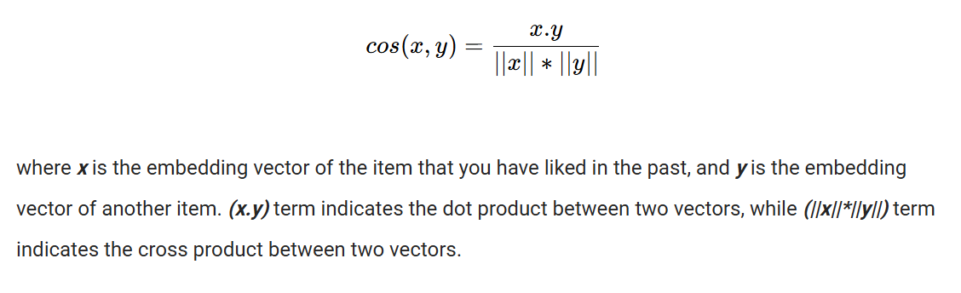
  - What kind of model to use?
- Content-based filtering (only based on YOUR data)
- Uses cosine similarity for recommendation system.
- Range is (-1,1). -1 most dissimilar, 1 is most similar
- Key term: user matrix, item matrix, feature, user-item matrix
- TF-IDF (Term Frequency-Inverse Document Frequency) or count vectorizer for converting text into numerical representation of specific features so the model can learn
-
  - How to deploy?

Model implementation:
Have user matrix and item matrix and use algo (such as dot product similarity, pairwise distance and cosine similarity) for content recommendation.

Dot product similarity:
- Useful for two numerical repr of things
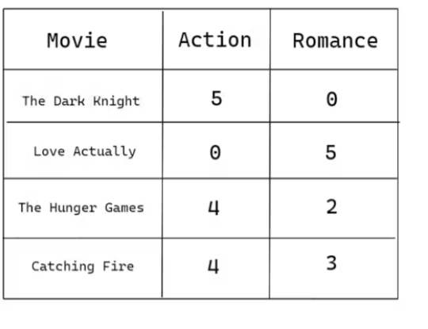
- 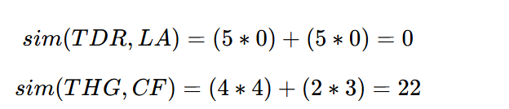
Pairwise distance:
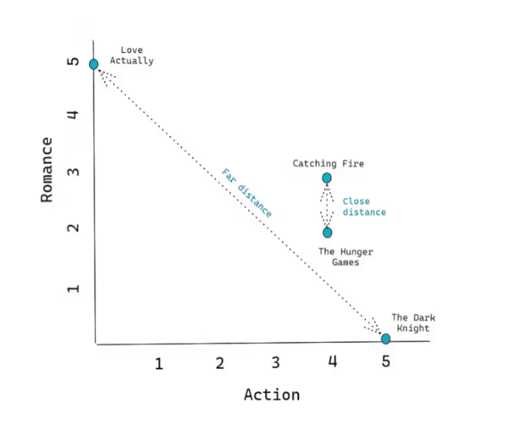
- Using the Euclidean distance to find the distance
- Longer the line, the more unrelated it is and vice versa.
Cosine similarity:
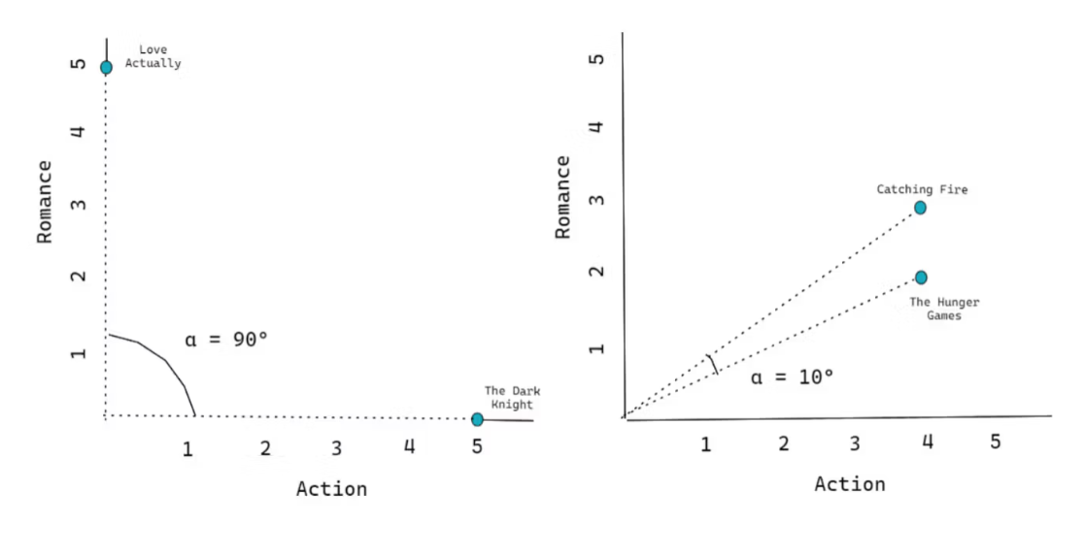
- Larger the angle, the more unrelated they are.
- The cosine function map the values of angle into range of [-1.1]
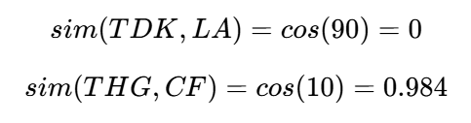

In theory, the user vector will be of the average of imdb, rotten tomato ratings.

Using the TF-IDF for text analysis when it comes to the relevancy of a certain word in a document compared to a collection of documents. It has an inverse relation to the frequency of appearance of the word compared to its ranking. The ranking is a score, higher the score higher the importance.
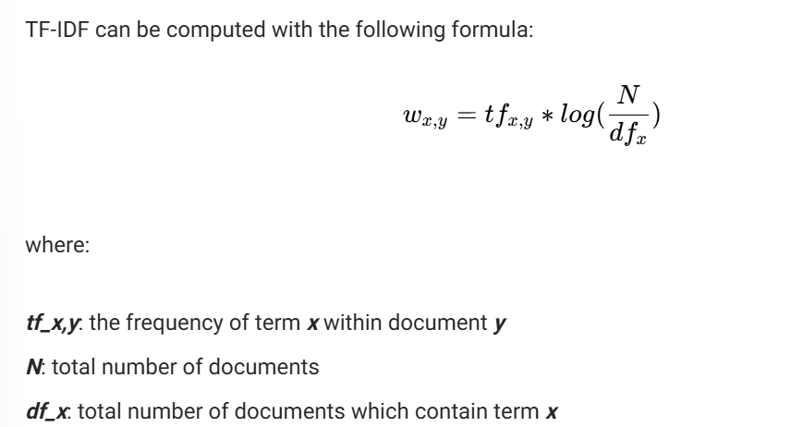
It’s range is [0,1].

End-user experience:
The user go to the website, log into their account which contains their history of movies, they can choose to add or remove their movies history. Then they press generate next 3 movies and the website will give them those 3 recommendations.

Data contains their movies history, the ratings are crowd-sourced, gotten from OMDb. (THE USER DO NOT RATE THEIR OWN).

Terrific sources:
https://www.stratascratch.com/blog/step-by-step-guide-to-building-content-based-filtering/
https://www.youtube.com/watch?v=MFSFcPsMsuE

